MemorY game

**INTRODUCTION :**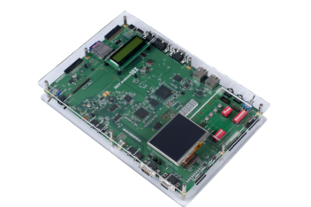 UTLP (Unified Technology Learning Platform) is an ardent facilitator for aiding engineers gain hand-on, learn and understand complex and advance technologies simply. Besides , UTLP also concentrates on making students and freshmen industry read as it gives them the experience of working in real time .Eventually UTLP embraces modern technologies to bridge the gap between academia and industry. It increases individually learning towards subjects and supports and motivates students towards building and integrating concepts keeping in mind organizational practices . It also promotes and expedites Entrepreneurship and Research within the country.

**ABSTRACT :**

Memory game is a game that require player to view the displayed images within the given time limit. As the name implies participants view the images and they need to find the correct order of images displayed in the options .Build your memory with this memory challenge game. Initially it displays set of images in the given time limit. After that the options will be displayed continuously. From that we should select the correct option. After the time gets over it displays the score in the 7 segment LED. The status of the game is displayed in the CLCD.

**FEATURES:**

* **Visual memory training.**
* **The game includes several set of images.**
* **you must memorize a board with several pairs of images.**
* **Regular mental and concentration exercise can greatly improve our photographic short term memory**
* **Train your memory , concentration , accuracy , attention , the speed of thinking and logical skills and much more.**

**FUTURE IMPLEMENTATION:**

Different levels of difficulty. Different levels of difficultie can be added Charming music and sounds can be included The game can be enhanced with 3D graphics. A multiplayer option can be added in the future

**CONCLUSION:**

Play memory games are full of fun for people of all age groups. As the level of game increases everytime , you deal with a higher difficulty level that helps to boost the brain. Enhance visual discrimination.